Lab Report

Lab 2

Section 9

Submitted By:

Conner Spainhower

Submission Date:

9/11/2019

**Lab Problem**

The purpose of this lab was to solve simple problems with C and start learning how C works. This started out with creating a program and adding some inputs while also learning how to compile, debug, and run the program until it works. Once this was accomplished, we moved on to harder problems such as conversions and programming the Pythagorean Theorem.

**Analysis**

There were 5 parts to this lab. The first section was creating your own program and that gave me some problems right off the bat. I had to figure out how to open the program, what mistakes I made, and how to output what I need. All of these were figured out in time due to some analysis and problem-solving.

The second part didn’t take long, but I still had to figure out a way to print my output as the volume of 3 inputs from the user. This involved the equation: V = w * h * l. The images (all on page 4) on the left shows the input and the image on the right showed the output. On the bottom, it shows the output after I implemented the equation for the volume for the rectangle prism.

Part 3 was interesting and took me the longest to solve. It was debugging and figuring out why the outputs weren’t outputting correctly. After some time, I had everything solved and output correctly, as shown in the figure below on page 4.

Part 4 was just simple arithmetic, and took longer to type than solve. It did have some outputs that were not working as they should, but this is because ints and doubles were mixed up so it would output only one of the functions.

Part 5 was programming the Pythagorean Theorem, which required some math functions that had to be input in manually. This involves the sqrt() function and the pow() function. The output is on page 4.

**Design**

The biggest thing I did to help me solve these lab problems was breaking it down to the bare bones and building it all together. For the first few sections, it is almost too easy to put into words as all I do is juvenile everyday problem solving. I asked questions such as: “What do I need from the user?”, or “What equations can I use to achieve this goal?”. Once I get these answers, it changes the complicated problem into a simple step-by-step instruction guide.

After I got these questions answered, it was time to implement some code. So far, there haven’t been too many major problems I couldn’t figure out, but sometimes I have to change ints to doubles or alter equations to do what I need them to do instead of outputting errors.

**Testing**

After planning the output very carefully, it was time to compile and run. I had some problems at first with compilation errors, as I couldn’t figure out why my code wasn’t outputting correctly, only to figure out it was because I hadn’t compiled beforehand. Next, I had some problems on step 3 when the outputs weren’t working correctly. I had to change some simple errors such as changing a %d to a %lf for double outputs. On step 4 I had the problem of all the values printing out with no space between them. I had to eventually put a “,” in-between them so they weren’t all scrunched together.

Step 5 was surprisingly easy, as I had memorized the math functions from the homework, so there weren’t any problems with programming that one.

**Comments**

After the lab was done, I was satisfied with my results. I figured out that I have understood what I have been taught so far and I reinforced my understanding of C with this lab. I personally wouldn’t change this lab at all, as it put an appropriate amount of challenge to the individual and filled the time allotted to do the lab. I overcame each challenge generally quickly and figured out how to do some basic functions in C.

Part 2:

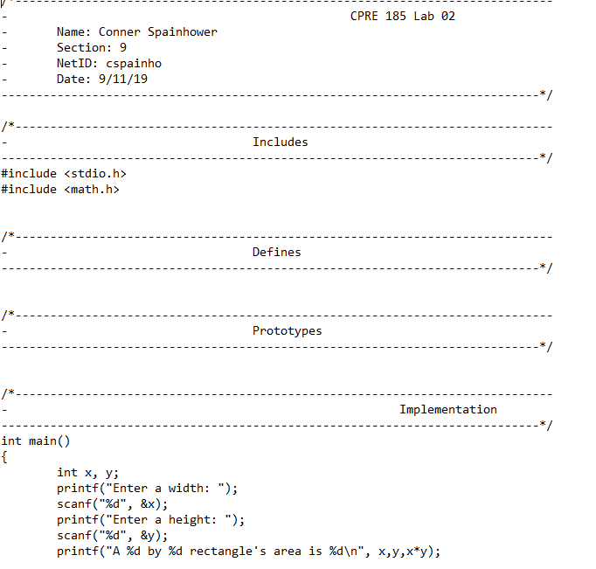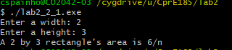

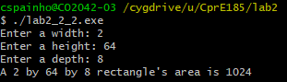

Part 3:

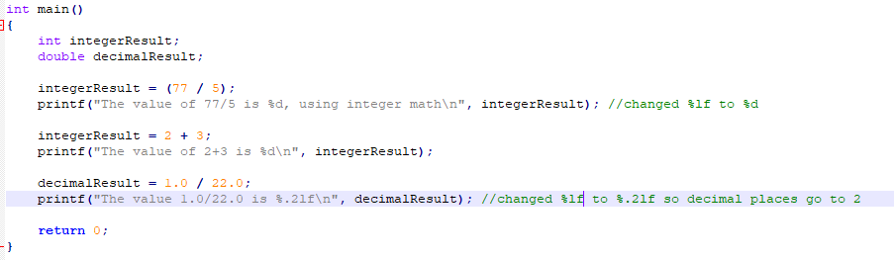

Part 5:

